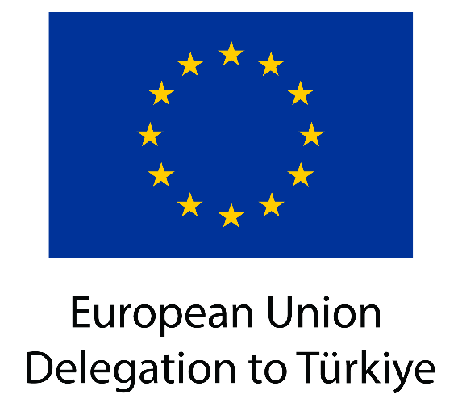

EU and Türkiye deepen cooperation in the green and digital transition

Today, Iliana Ivanova, European Commissioner for Innovation, Research, Culture, Education and Youth, and Mehmet Fatih Kacır, Minister of Industry and Technology of the Republic of Türkiye, met in Istanbul for the second EU-Türkiye High-Level Dialogue on science, research, technology and innovation. This marks a significant milestone in EU-Türkiye research and innovation cooperation.
The two sides have announced that three innovation programmes from Türkiye are now certified to take part in the European Innovation Council (EIC) Plug-in scheme, which will enable them to submit projects from their portfolio directly to the full application stage of the EIC Accelerator. In addition, the European Institute of Innovation and Technology (EIT) will set up a Community Hub in Türkiye by the end of the year. Moreover, the Commission’s Joint Research Centre has supported the launch of Türkiye’s initial roadmap to support the design of regional Smart Specialisation Strategies.
Commissioner Ivanova and Minister Kacır exchanged views on EU’s and Türkiye’s science, technology, and innovation policies, putting an emphasis on the critical role of a skilled workforce in enabling innovation and technology transfer. They reaffirmed their commitment to intensifying cooperation in the aforementioned areas, aiming for closer and deeper integration of Türkiye in the European Research Area, including EU Missions and Partnerships under Horizon Europe, the EU research and innovation programme.
The meeting was an important moment to assess ongoing co-operation in critical sectors and to discuss future opportunities for collaboration between academia and business. The EU and Türkiye agreed that a stronger integration of research and innovation capacities and technology transfer activities, coupled with human capital development, are key to succeeding in the ongoing green and digital transitions.
The significant achievement of Turkish scientist Rana Sanyal, winner of the 2023-2024 European Prize for Women Innovators, was highlighted as a successful result of the EU-Türkiye innovation cooperation.
This afternoon, Commissioner Ivanova and Minister Kacır will also open the Boğaziçi University Life Science Centre. This centre has been upgraded thanks to nearly €8 million support from EU programmes. The Centre will perform cutting-edge research on protein sequencing and cancer therapy.

Background
Türkiye has participated in EU research and innovation programmes since 2003, with a total of €743 million in EU support to Turkish researchers and innovators. Their participation in Horizon Europe, the current programme, has been particularly successful. EU contribution to Turkish entities reached €91 million in 2022, supporting participation in EU Missions and Partnerships, Science, Technology and Innovation Networks such as Cooperation in Science and Technology (COST) and EUREKA, as well as in Marie Skłodowska-Curie Actions, supporting the training, skills development and mobility of researchers and international doctoral programmes. Additionally, under the Instrument for Pre-Accession Assistance (IPA), the EU has provided more than €700 million financial support to the competitiveness and innovation of the Turkish economy, funding projects boosting productivity, technology development and innovation as well as promoting green and digital transformation.
The first EU-Türkiye High-Level Dialogue on science, research, technology, and innovation took place in Brussels on 15 November 2022, focusing on aspects of the European Green Deal in boosting human capital development, innovation and technology transfer.
On 1 September 2023, the two sides signed an agreement associating Türkiye to the Digital Europe Programme. This enables Turkish businesses, governmental bodies and other eligible entities to take part in projects implementing digital technologies. The agreement will also enable the establishment of Digital Innovation Hubs in Türkiye.

Quotes
“Close cooperation in research and innovation with like-minded partners is a key priority for the European Union. This is why our high-level dialogue was a milestone. We discussed how to deepen our already very successful cooperation even further. Together, we can succeed in the digital and green transitions quicker.”
Iliana Ivanova, Commissioner for Innovation, Research, Culture, Education and Youth
“Turkish research and innovation ecosystems have emerged as pivotal collaborators in EU research and innovation programmes. In line with Türkiye’s status as a candidate country, we acknowledge with contentment that the engagement between Türkiye and the EU in the spheres of STI has yielded concrete outcomes. Adherence to principles of mutual benefit, between Türkiye and the EU, lays strong foundation to address global challenges and foster scientific advancement.”
Mehmet Fatih Kacır, Minister of Industry and Technology of the Republic of Türkiye

